|  |
| --- |
| TECHNICAL REPORT |

|  |
| --- |
| Electrical & Computer Engineering & Computer Science (ECECS) |

|  |  |
| --- | --- |
| SPRING 23 |  |



Contents

Project Name 2

Executive Summary 2

Technical Report 3

Highlights of Project 3

Submitted on: 3

Abstract 4

Methodology 5

Results Section 5

Discussion 6

Conclusion 6

Contributions/References 7

|  |
| --- |
| Recession Prediction |

|  |  |  |
| --- | --- | --- |
| Executive Summary The objective of this project is to create a predictive model for analyzing the previous recessions and indicate future ones. Based on GDP, consumer spending, unemployment, and layoffs, a Python-based machine learning algorithm, logistic regression is used to forecast recession. The project includes gathering data, preprocessing it, choosing features and deciding target variable, selecting model, splitting data for training a model, and assessing it. And then the model's effectiveness is evaluated based on how well it predicts the desired value. | | |
| person at a table writing in a notebook with people around | | |
| **Team Members:**  Ajay Kumar Reddy Vemapati  Likhita Yakanuru  Waseema Begum | **Questions?**  Contact :  [avema1@unh.newhaven.edu](mailto:avema1@unh.newhaven.edu)  [lyaka1@unh.newhaven.edu](mailto:lyaka1@unh.newhaven.edu)    [wbegu1@unh.newhaven.edu](mailto:wbegu1@unh.newhaven.edu) |  |

|  |
| --- |
| Technical Report |

|  |  |
| --- | --- |
| **Recession Prediction** |  |
| Highlights of Project The project focuses on training the model with past years data and concluding if there will be any recession happening soon in future based on analysis.  Data was collected from <https://fred.stlouisfed.org> and preprocessed to convert it into quarter intervals. Logistic regression is a powerful and interpretable model that produces a probability score for each observation, it is simple to implement and computationally efficient. Model is trained by splitting the complete dataset into 70% of training set and 30% of testing set. Its accuracy is tested, and maximum likelihood is estimated.  The model can be used to envision the recession by assuming the features considered for deciding the outcome. Submitted on: 04/30/2023. |

## Abstract

A recession is an economic situation that arrives when the circulation of money in the economy is low for two consecutive quarters. Recession is calculated and analyzed according to the growth in GDP, the growth in the unemployment rate or Layoffs, and the growth in Personal Consumption Expenditures.

For above factors, following values has been taken as cut off to decide whether the economy was in recession or not:

GDP: percentage change in two consecutive quarters decreased.

Unemployment Rate: Greater than 7.5%

Layoffs: More than 5000 per quarte

Personal Consumption Expenditures: percentage change in two consecutive quarters got decreases.

The final decision is then made by combining all the above factors.

## Methodology

The methodology used for this solution is CRISP-DM (Cross Industry Standard Process for Data Mining):

Business Understanding:

Examine the information on the indicators (Layoffs, GDP, unemployment, and consumer spending) to determine whether a recession is likely to occur.

Data Understanding:

Gather information and carry out exploratory analysis to learn about the properties and structure of the data.

Used data sets such as Layoffs Dataset, Unemployment as per US state, Personal Consumption Expenditures and USA GDP dataset from Fred site.

* Data Preparation:
  + Cleaned the data, did feature engineering, and updated the data into a quarterly format for modeling. Taking care of missing values, eliminating outliers, and adding new features.
* Modeling:
  + The Logistic Regression model is constructed based on the available data using methods like clustering, classification and analyzing the previous recession patterns.
* Evaluation:
  + Utilized relevant measures to assess the performance of the models, such as accuracy, precision, and recall. Depending on the findings of the evaluation, concluded the future outcomes.
* Deployment:
  + Deploy the models in a production setting and monitor their performance.

## Results Section

Analyzing the outcome of model by plotting each feature with respect to time:

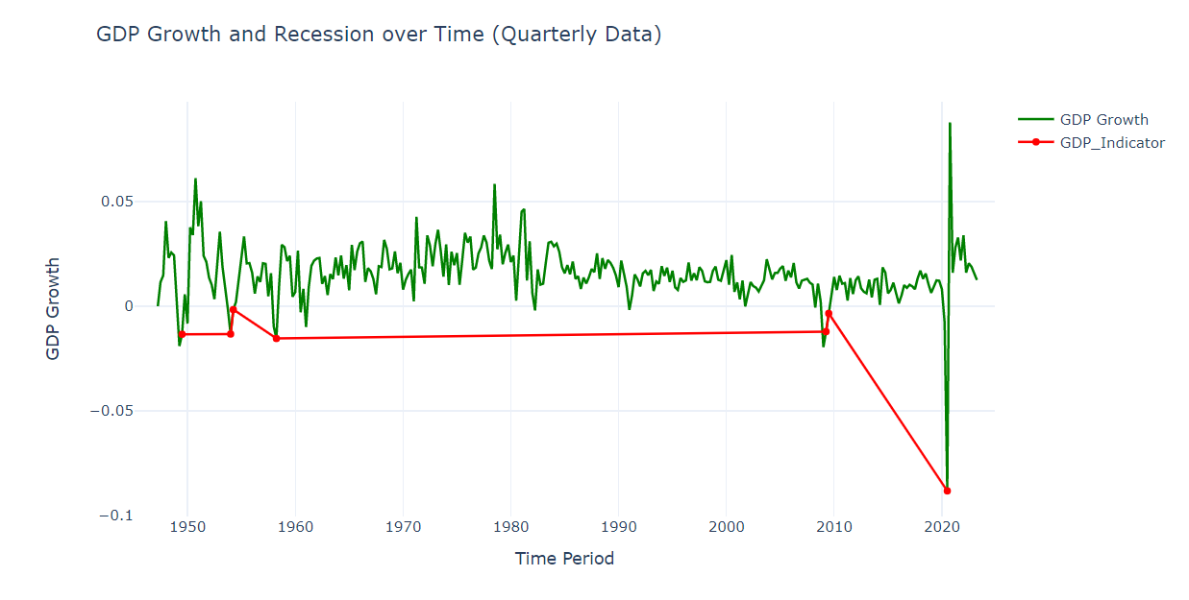

## Discussion

As per the above graphs, it is noticeable that after 2020, all the deciding features are constantly improving and even with the fluctuations in recent quarters, it is not going to be below the cut off mark in the near future. Hence, we can conclude that there won’t be any recession soon even with frequent change in economic factors.

## 

## Conclusion

To summarize, we used a logistic regression model to predict whether a recession is likely to occur based on the percentage change in GDP, consumer spending, and the average number of layoffs over the previous quarters. We also calculated the accuracy of the model using the test data. This can be customized further to suit specific requirements and data.

Also, it is important to note that no single indicator is sufficient to determine whether an economy is in a recession. A combination of these indicators should be analyzed to get a clearer picture of the overall economic situation. Additionally, it is important to consider the context and other factors that may impact the economy, such as government policies, international trade, and financial market trends.

## Contributions/References

[Gross Domestic Product (GDP) | FRED | St. Louis Fed (stlouisfed.org)](https://fred.stlouisfed.org/series/GDP)

[Unemployment Rate: Aged 15-64: All Persons for the United States (LRUN64TTUSQ156S) | FRED | St. Louis Fed (stlouisfed.org)](https://fred.stlouisfed.org/series/LRUN64TTUSQ156S)

[Layoffs and Discharges: Total Nonfarm (JTSLDL) | FRED | St. Louis Fed (stlouisfed.org)](https://fred.stlouisfed.org/series/JTSLDL)

[Personal Consumption Expenditures (PCE) | FRED | St. Louis Fed (stlouisfed.org)](https://fred.stlouisfed.org/series/PCE)

[Recession Analysis using Python | Aman Kharwal (thecleverprogrammer.com)](https://thecleverprogrammer.com/2023/02/20/recession-analysis-using-python/)